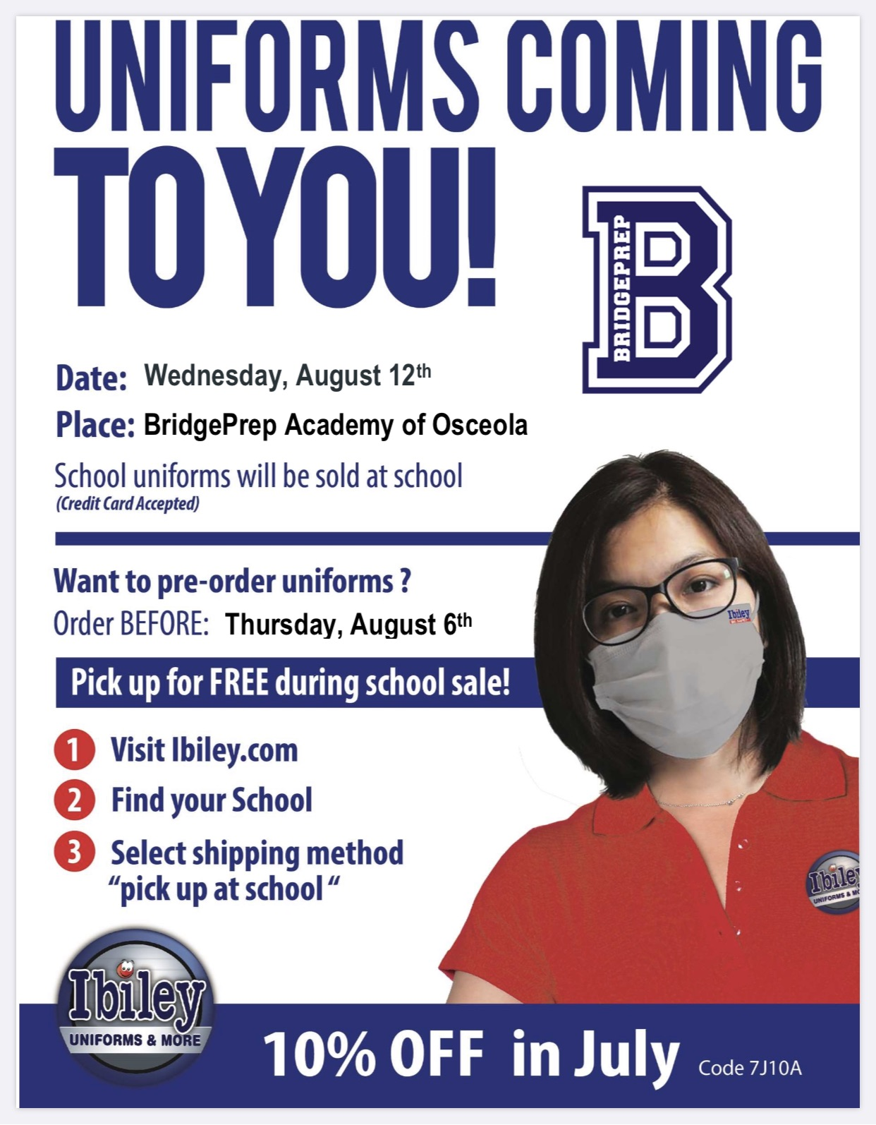

**Hours: 9:00 am through 6:00 pm**

**Uniform sale reschedule for August 12, 2020**